**Assignment 7**

**Description:**

1. Assume that you have the following JavaScript code:

Code – 1

const person = {

firstName: "Nick",

lastName: "Anderson",

age: 35,

sex: "M"

}

const { firstName: first, age, city = "Paris" } = person; // That's it !

console.log(age)

console.log(first)

console.log(firstName)

console.log(city)

Code – 2

let sum = (a, b) == {

let result = a + b;

return result;

}

let result1 = sum(5, 7);

console.log(result1);

let’s find the correct log for output?

**Show the output for Code -1**

1. **Get the console log output of person?**

Yes, after few changes.

1. **Using const can we define a variable in above code or not.**

Yes

1. **firstName is not able to get the log into console find out the correct code snap.**

console.log(person.firstName)

**Output:**

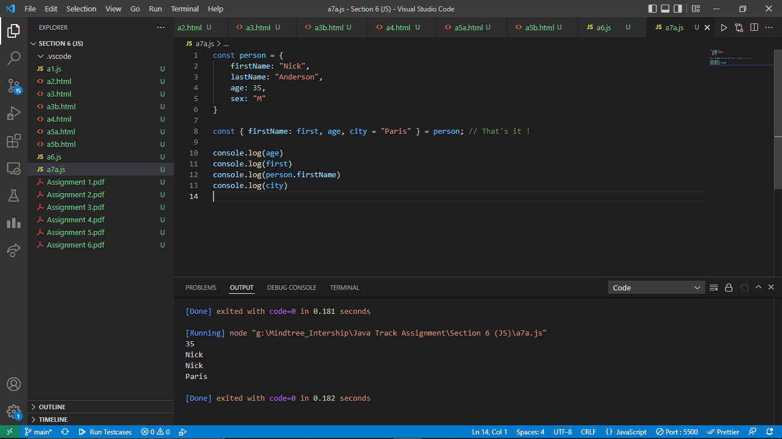

**Show the output for Code -2**

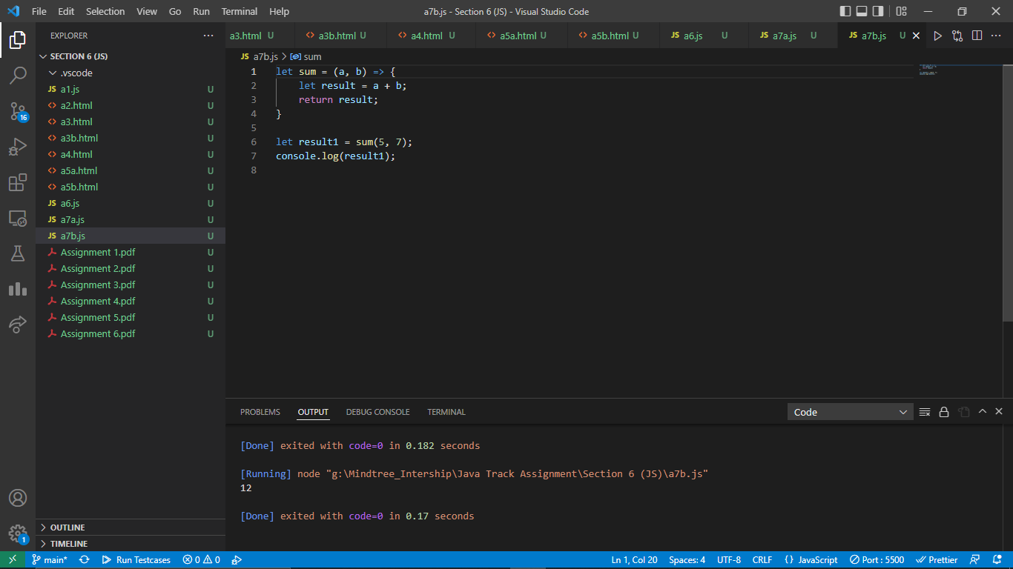

1. **Get the console log output using arrow function if any code or syntax error.  
   Done**
2. **While implementing arrow function consider output should be 12.**

**YES**

**Performance Outcomes:**

Upon successful completion of the assignment, the participant is well versed in

1. User are able to create const and use with log and Destructuring Arrays and Objects.
2. Knowledge to maintain the output value using log based on string.
3. Use are able to use and know how the arrow function working style.